Simulation Modeling: Risk Processes and Systems

harsh kadia

Re-designing the swipe card system to enter 115 New Cavendish St

UNIVERSITY OF WESTMINSTER

2019

Table of Contents

LITERATURE REVIEW: 1

PROBLEM AND SYSTEM DESCRIPTION: 4

KEY DATA 7

SIMUL8 8

EXPERIMENT AND OUTPUT ANALYSIS 9

CONCLUSION 10

REFERENCES 11

APPENDICES 12

Figure 1: 12

Figure 2: 12

# LITERATURE REVIEW:

Basically, there are two types of queuing models-physical and non-physical queues. Let’s say as an instance that the queue formed in a bank is termed as a physical queue, while a phone call to a service centre is termed as a non-physical queue. Queuing models also have some of the restrictions. For example, Scope and complexity could be restricted for the algorithms that they handle. Also, queuing models need unconventional assumptions which can be implemented which would not be very precise. To gain more precise characteristics on a real-life system, simulation is mostly used. It consists of programming specific software which can model the queuing system. Although it is more precise it may take some time for the implementation of the model and to build the data for a particular problem. (Sadeghi, N., Robinson Fayek, A., Gerami Seresht, N. (2015))

For modeling queues, two quantitative methods can be used. The problem solved by using Microsoft Excel is the steady-state equation, whereas the use of simulation tools like anylogic, simul8 is the simulation method. Simul8 enables haphazardly created preliminaries to be performed dependent on the numbers attributed to the model. It likewise empowers clients to modify the administration and landing likelihood capacities, change the line control and set a limit on the line, which is required to deliver results that speak to every autonomous line model. To test the parameters of each lining model, a lot of situations will be led for each lining model. The relentless state conditions require the administration and entry rate over a specific timeframe which is one hour for this analysis, while the Simul8 programming requires the time among entries and the time it takes to serve one unit. (Brailsford, S.C. and Hilton, N.A. (2001))

There are many fluctuated settings, for example, medicinal services, supply chains, assembling and correspondence frameworks. These sorts of models have their restrictions because of their capability to turn out to be of all time obstruct in halt, or a dangerous grasp of assets. This may occur in models where deadlock circumstances are effectively balanced as a general rule. Deadlock is caused by locking. During his time that server is inaccessible to start the other service of the client.

Example:

An example of the previous statement is in the healthcare system where deadlock may affect a set of processes both in the real situation as well as in analytical stochastic models and simulations. A deep understanding of the consequences of deadlock in a discrete event simulation may help to overcome its effects and build more efficient models. The following schema simplifies the interaction between Hospital and Community Care. (Palmer, G.I., Harper, P.R., Knight, V.A. (2018))

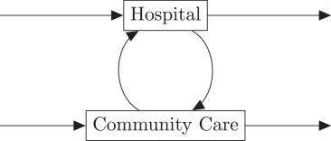

The lack of hospital beds will force the community care employees to provide their services to patients unable to access the hospital, while patients ready to come back home after a hospital stay will remain in their beds because of the lack of community care packages. The loop described has a non-zero probability of everyone blocked in their positions with no possibility of a solution. Although the author of the paper claims the irrelevance of this situation in the operating system management due to the easiness in swapping of patients between the different processes, the loop must be omitted from the simulation. It will provoke restriction to the model functioning difficult to solve.

What-if situations can be studied through discrete event simulation by the use of management policies and scheduling methodologies, this particular kind of simulation requires accurate calibration of the input to reach reliable outputs. However, a precise selection of inputs is of paramount importance in the estimation of the overall model causing many discussions around the topic. The subselection of quantitative and qualitative parameters ensure that the results will be close to the real outputs, whereas the wrong evaluation of the initial input can produce huge errors and incorrect outcomes. (Leemis, L.M. and Park, S.K. (2006))

Each activity in the simulation project must be represented by its probability distribution which is the mathematical translation of the latent uncertainty embedded in it. The probability distribution derived from the study of each phenomenon is the consequence of environmental conditions and the characteristic of the process itself. To infer the distribution descriptive of a process data of peculiar aspect that process must be collected and processed from real experiments.

The queuing system comprises of fundamentally four components: the procedure of client arrival, queuing rules, client service time and service system structure. The arrival procedures of the customer can be described by general entry, Erlang arrival, Bernoulli arrival, and so on. The queuing rule refers to the modality of acceptance of a customer which can be the loss, the first come first served, last served first served, random, priority service, random selection service, batch service and so on. The service time describes the amount of time necessary to process each requirement from a customer and the service system refers to the structure of the entire process consisting of the number of the service stations as the nodes of the schematic representation of the model as shown in the figure below. (Akhavian, R. and Behzadan, A.H. (2014))

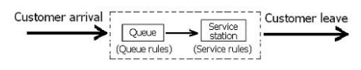

# PROBLEM AND SYSTEM DESCRIPTION:

Building and testing a simulation model to understand the queuing system for entrance and exit to the 115 New Cavendish St through speed gates.

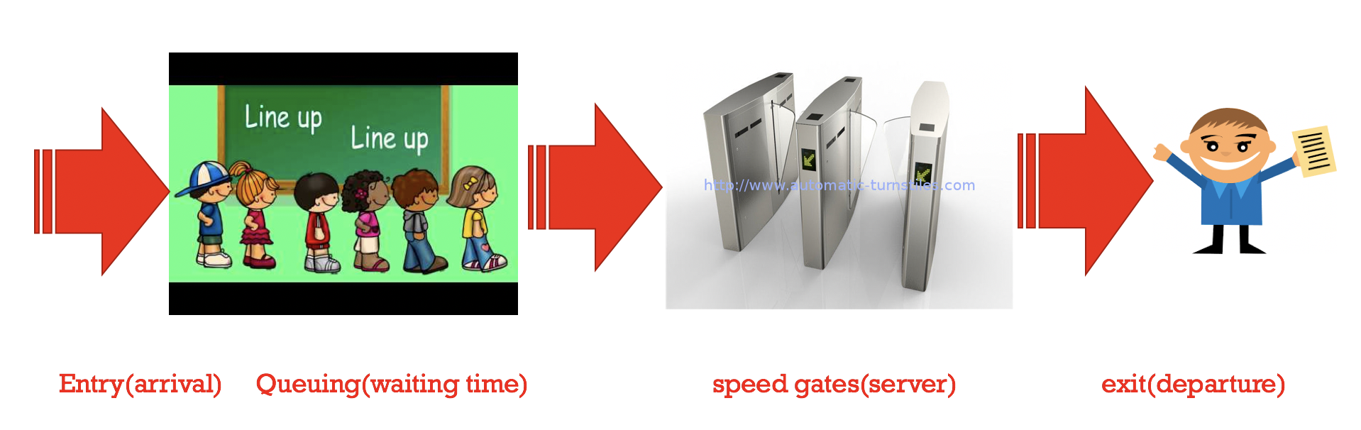

The primary goal of this mini project is to simulate the queue for 115 New Cavendish Street by using swipe card speed gates by analyzing the output of the simulated model.

The process flow diagram of the system is as follows:

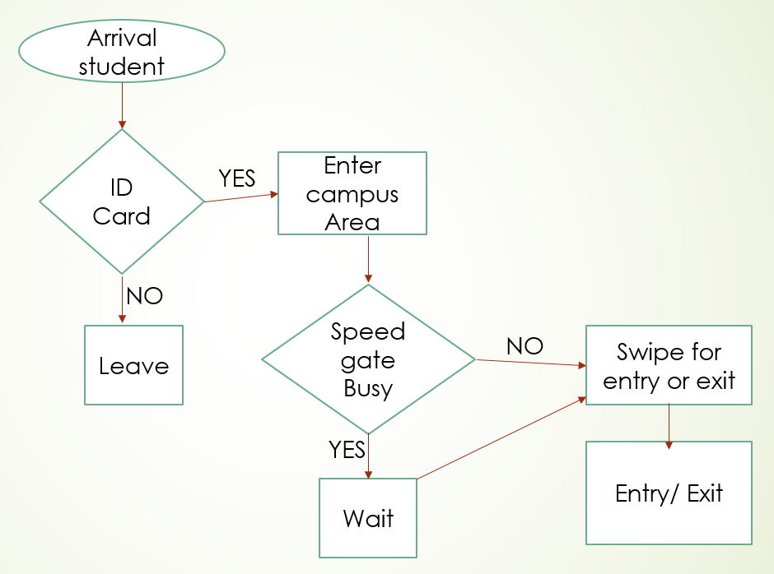

The first activity is the students/staff arriving at the speed gates.

Then the student/staff who has an ID card will have to swipe the ID card in order to access the speed gates of the University campus.

Student/Staff has to wait in a queue if the speed gates are used by any other staff/student.

Students can access the system by swiping their ID card if the speed gates are idle.

Showing the real-life scenario for this mini project in a broader view is as follows:

Here, Red lines represent activity on the system, Green line shows the time interval and it is over a period of time.

Students tend to come in group or individual, out of which some of them have ID cards in their bag which could cause a delay for the person following in a particular gate.

In our case, we assume that the students tend to use gates 1, 2, 3 and 4 more than 5 and 6 while entering because there seems to be as a fuzzy logic of not using the 4,5 and 6 gates as the sofa at the entrance blocks the last 3 speed gates as per our assumption.

Moreover, we have used Discrete Event Simulation method for the mini project as it is a viable way to deal with the queuing system. Despite the fact that an ideal arrangement can’t be easily controlled, it helps in the innovation of various What-if queries which can be productively done using Simul8 software.

Monte Carlo strategy helps in understanding the framework by using repeated random sampling for obtaining outputs. It gives a scope of potential results and the probabilities that will happen for any decision of activity for the user to make a decision.

System Dynamics is a method to solve complex systems that are non-linear. It is broadly utilized for ecological systems, policy analysis, and so on. Vensim software is used for the simulation on System Dynamics.

Furthermore, types of queuing models are:

1. Single Server – Only one server
2. Multiple Server – More than one server

Here, the server is the one who provides a service.

M (Arrival rate)/ M (Service rate)/ 6 (Number of servers): /∞ (Queue length)/ ∞ Population (Candal notation)

Arrival Rate -> Person that enters the system and it is denoted by Poisson distribution -> λ

Service rate -> It is an exponential distribution which is denoted by µ

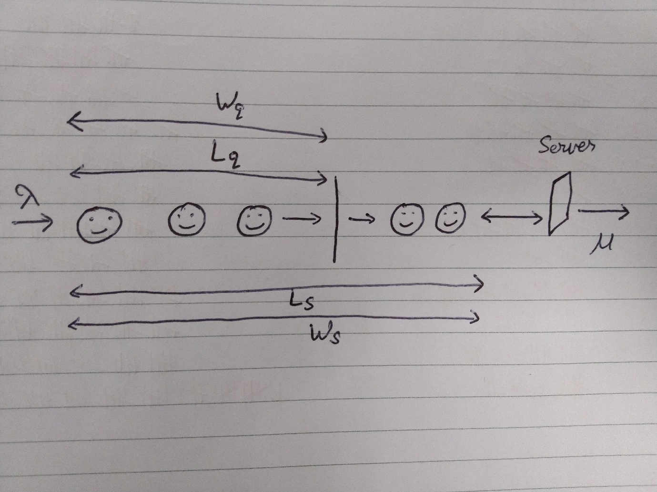

Here, speed gates are the server and the people (students/staff) is the customer. When the people who use the service, the rate of this will be λ (This is not fixed. It may vary). The time taken by the speed gates to open the gate by scanning the valid Identity of the person will be denoted by µ. Hence, this will be server time.

Length of the queue – The people waiting in the queue before taking service is considered as the length of the queue - 3

Length of the system – The people waiting in the queue as well as taking service from the speed gates is considered as the length of the system - 4

Waiting time in a queue – Person coming and joining a queue till a person receives a service is considered as waiting time in a queue (Wq)

Waiting time in a system – Person enters the queue till a person receives the service and goes out of the system is considered as waiting time in a system (Ws)

Ρ (Rho) = λ (Arrival rate)/ µ (Service)

Deriving a formula from this for:

An average number of customers in a system Ls = λ / µ - λ. Dividing by µ in the denominator as well as in the numerator will give us (λ/µ) / (µ- λ /µ). As, Ρ (Rho) = λ / µ, the final equation will become

Ls = Ρ/1- Ρ (Rho)

An average number of customers in a queue Lq = λ2/ µ (µ - λ). Here, after dividing the equation by µ in the denominator as well as in the numerator, the final equation will become Lq = Ls * Ρ (Rho)

Waiting time in a system Ws = Ls / λ = ((Ρ / 1 – Ρ) / λ)

Waiting time in a queue Wq = Lq/ λ = Ρ * Ls/λ

Probability for no customers in the system = Ρ0 = 1- Ρ

The server is not free = 1- Ρ0

Probability of n customer in the service system = (1- Ρ) Ρn. Therefore, Ρn = Ρn * Ρ0

# KEY DATA

The data was collected manually by counting the number of incoming and outgoing persons entering, exiting and blocking the speed gates of the University campus. The incoming population for using the service (speed gates) is exponential distribution.

The number of staff/students entering and leaving the campus via speed gates was gathered with time interim. For the speed gates time, we noticed time by utilizing a stopwatch counting the idle time and the service time. The data we collected was between 8-11 AM in the morning, 12-2 PM at noon time where the crowd was the highest due to the lunchtime and 4-6 PM in the evening.

Assumptions and Analysis:

* The feature of this queuing system includes University as a system, Staff/Students as the input of numbers and servers to be the speed gates.
* The capacity of the system in unlimited.
* For the simulation of this system, the process of arrival of the people is random and distribution of it is exponential.
* The pattern we noticed was First In First Out.
* In this simulation model, Routing in is the priority for the Routing out as it is based on the people coming in the campus.
* Also, some students/staff that creates delay while entering or exiting the system is occurred due to the students/staff searching for their ID cards in their bags or pockets when they are standing in front of the speed gates for the service. Whereas, in all cases, the service time remains constant.

The data from 8 AM to 8:15 AM was 22 people as an incoming and 2 people outgoing through the speed gates. From 8:15 AM to 8:30 AM the count of people incoming was 40 and outgoing was 10 using the speed gates.

Furthermore, the number of people incoming and outgoing increases exponentially over time and it fluctuates depending on the time. In the morning, the number of people incoming was more as compared to the outgoing people. At noontime, both incoming and outgoing people have almost equal count of incoming and outgoing using the speed gates. At the evening, the number of people outgoing is more than people coming to the University using the speed gates.

The server’s ideal time and the service time for an interval of 15 minutes are as follows:

|  |  |
| --- | --- |
| Service_time | Idle_time |
| 00:01.600 | 00:15.760 |
| 00:05.860 | 00:04.610 |
| 00:25.870 | 00:05.180 |
| 00:07.510 | 00:06.810 |
| 00:00.520 | 00:22.120 |
| 00:01.370 | 00:43.090 |
| 00:00.710 | 00:15.740 |
| 00:03.800 | 00:09.860 |
| 00:09.800 | 00:17.170 |
| 00:00.610 | 00:07.070 |
| 00:04.200 | 00:03.400 |
| 00:00.890 | 00:14.400 |
| 00:00.630 | 00:14.140 |
| 00:00.310 | 00:13.700 |
| 00:06.790 | 00:12.910 |
| 00:01.600 | 00:01.600 |

For the speed gates, average service time is 0.3 and the maximum waiting time is 0.52.

# SIMUL8

**Data Needed:**

Number of incoming persons through speed gates

Number of outgoing persons through speed games

Number of people in the campus area

Number of people on the campus

Number of speed gates

**Layout:**

1. Start Point
   1. Student/Staff Entry from outside the University to the campus of the University

(In this Starting point, the speed gates priority is 1:campus_area (inside University) with Poisson distribution having an average of 0.13)

1. Queues
   1. The queue to the Speed gates for the people coming inside the University
   2. The queue to the Speed gates for the people going outside the University
2. Activity
   1. 6-speed gates out of which first 3 were mostly used from our analysis.

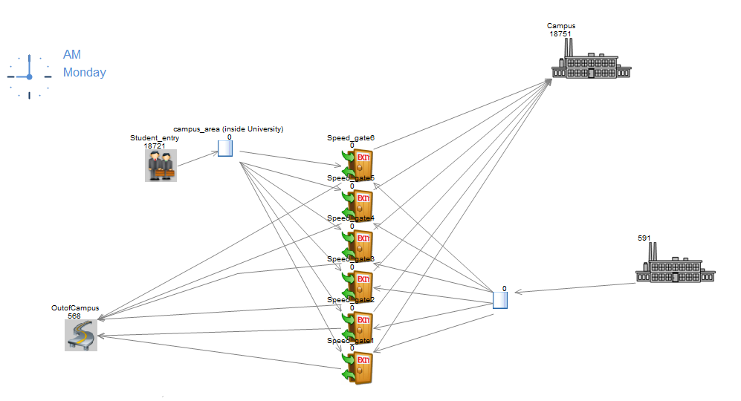

# EXPERIMENT AND OUTPUT ANALYSIS

The representation of the speed gates arranged in our universities is as above in the figure. The students enter through speed gates located on the university campus. In total, there are 6-speed gates available for students to enter. The arrangement is such because in case of any delay by the side of the student, for instance, the ID card of the student is in the bag, then at such times, other speed gates can lessen the delay time because the students waiting in the queue can shift to other speed gates. After entering through the speed gates, the students get dispersed in the university arena. The exact same procedure is there for students to go out of campus, they from the campus through the 6-speed gates exit outside. Now doing analysis on the usage and efficiency of the speed gates, I found the following results.

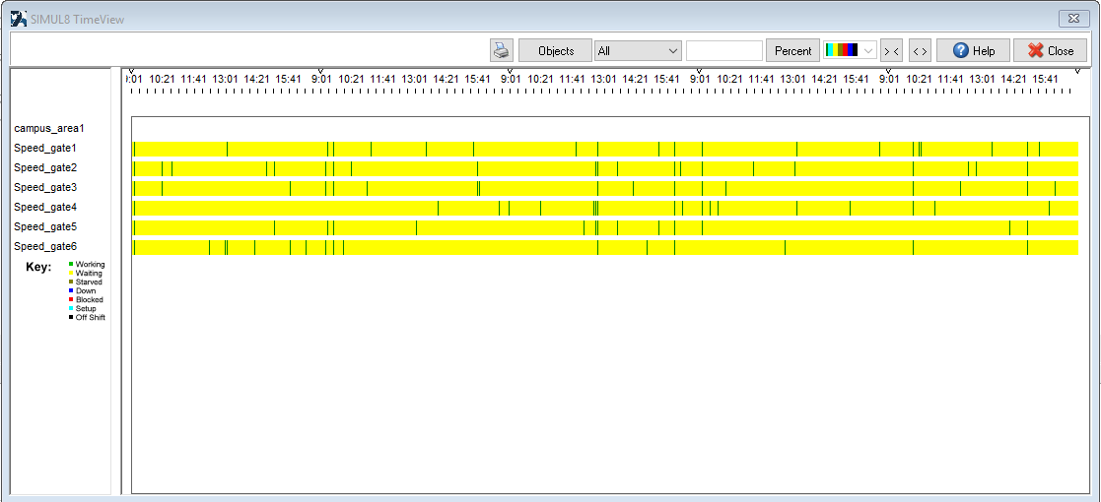

The average time interval at Student-entry area is 0.13 mins with a Poisson distribution of the data in the graph. At all the 6 speed gates, the data is distributed in Exponential fashion with the average time interval of about 0.05 mins. From the timeline graph, we can see that the yellow area (waiting time duration) is higher than the frequency of the green area (working time duration), we can also see from the graph that some gates are used more frequently than other gates and at specific times in a day the gates are used more frequently than other times in a day. This can create a bottleneck effect near the speed gate area.

When I collected data on the above timeline graph and from further research from Figure 1 and Figure 2, I found out that the highest utilized activity under bottleneck effect was under speed gate 1 and speed gate 4 for about 6.712% and 6.934% respectively, on the other hand, for potential efficiency gains, the lowest utilized activity was under speed gates 6 and 3 with an activity of 6.442% and 6.652% respectively. From all the above data, we can summarize that we can safely remove speed gate 6 without increasing the chances of queue near the speed gate area since there are other 5 gates which can distribute the queue load. Doing this may help us to use the area currently used by speed gate 6, we can use that area to build new and modern infrastructure for the university. But if we think to remove speed gate 5, the waiting time duration in the timeline graph will increase creating pressure on the rest 4-speed gates and due to this, there are chances of long queues in the area near the speed gates which is not good for the university. So, the current arrangement of the speed gates is good because it will help easy evacuation of place in an emergency situation and also for future, as in future with increase in number of students, the entry and exits of students will be more comfortable with an arrangement of 6 speed gates compared to a situation with just 5 speed gates.

# CONCLUSION

The queuing system of 115 New Cavendish Street was very intriguing. We analyzed that gate number 1 and 2 were mostly used as there was an unseen fact that people didn’t tend to use gate number 5 and 6 because of the sofa at the entrance of the campus which causes the people to move straight towards gates 1 to 4 while entering the campus. It’s not that the gate 5 and 6 is not used at all, but it is mostly used when the students/staff exits the campus.

According to me, 5-speed gates should be the ideal ones as per the current situation. But hopefully in the future, when the number of students/staff increases this would be definitely helpful. However, I believe that the sofa at the entrance of the campus which blocks the gates 5 and 6 should be moved to the opposite side from the current position of the sofa so that all 6 gates can be used effectively.

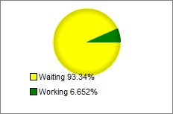

Also, the above chart concludes that waiting time outweighs the server time and it can be seen that all the gates are used collaterally.

# REFERENCES

Akhavian, R. and Behzadan, A.H. (2014). Evaluation of queuing systems for knowledge-based simulation of construction processes. *Automation in Construction.*47 37-49. Available from <https://www.sciencedirect.com/science/article/pii/S0926580514001587> .

Brailsford, S.C. and Hilton, N.A. (2001). A comparison of discrete event simulation and system dynamics for modelling health care systems, Glasgow Caledonian University.

Leemis, L.M. and Park, S.K. (2006). Discrete-event simulation Upper Saddle River, N.J: Pearson Prentice Hall.

Palmer, G.I., Harper, P.R., Knight, V.A. (2018). Modelling deadlock in open restricted queueing networks. European Journal of Operational Research. 266 (2), 609-621. Available from <https://www.sciencedirect.com/science/article/pii/S0377221717309529> .

Sadeghi, N., Robinson Fayek, A., Gerami Seresht, N. (2015). Queue performance measures in construction simulation models containing subjective uncertainty. Automation in Construction. 60 1-11. Available from <https://www.sciencedirect.com/science/article/pii/S0926580515001788> .

APPENDICES

## Figure 1:

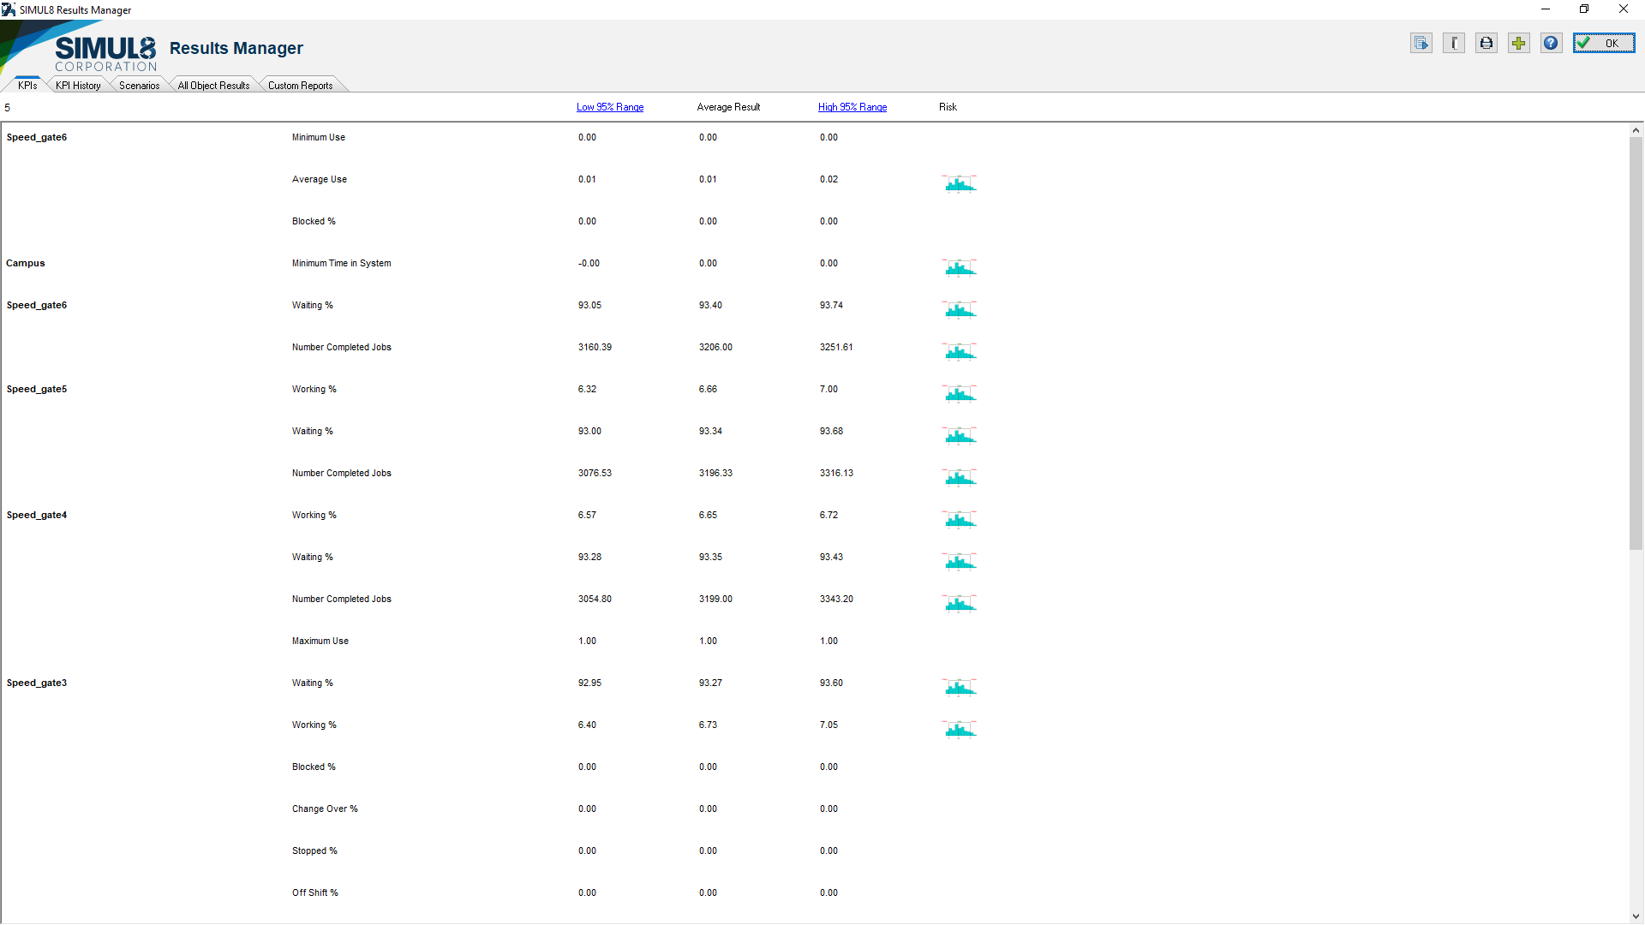

## Figure 2:

